**PLEASANT TOURS**

**Developer Guide**

|  |  |  |
| --- | --- | --- |
| **Faculty** | **Miss Neelam Malik** | |
| **Batch** | **2209B1** | |
| **Group** | **C** | |
| **Serial No.** | **Enrollment Number** | **Student Name** |
| 1. | Student1412237 | MUHAMMAD AQDAS |
| 2. | Student1412235 | ABUBAKAR ALI |
| 3. | Student1407855 | UBAID UR REHMAN |
| 4. | Student1412215 | MUHAMMAD WASAY |

**TABLE OF CONTENT:**

Documentation ---------------------------------------------------------------- 1

Acknowledgement ------------------------------------------------------------ 3

Certification -------------------------------------------------------------------- 4

Problem Statement ------------------------------------------------------------- 5

Screen Shots --------------------------------------------------------------------- 8

Task Sheet Review 2 --------------------------------------------------------- 13

Task Sheet Review 3 ----------------------------------------------------------14

**ACKNOWLEDGEMENT**

We are thankful to Almighty, ALLAH that by His grace we have been successful. we presenting on Dream Weaver in your hands. We have tried our best to take all relevant important topics in consideration so that this project may become comprehensive.

This is our First Year Semester E-project. We have tried our best & struggled for a better outlook to come. This project has been developed in Dream Weaver. We choose to make Webpage for Garden World.com as a project. We find easy to do coding in Dream Weaver.

We earnestly hope that this project will provide all the necessarily information required for the user to fulfill their inspiration. However, suggestions for improvement of the project will be thankful received & acknowledge.

**THANKING YOU……**

**CERTIFICATION:**

This is to certify that,  
MUHAMMAD AQDAS , ABU BAKAR ALI , UBAID UR REHMAN , MUHAMMAD WASAY

Have successfully designed, develop and submitted the Festivals website.

**Problem Statement**

Pleasant Tours is into selling various tour products. They have predefined tours with

itineraries. The company advertises by distributing the pamphlets, advertising on

television and so on. Due to rapid development in internet field, the company

decides to launch a website where people will get all the information about the

various tour products available with them easily.

**Requirement Specification:**

**Hardware/ Software Requirements**

The Web site is to be created based on the following requirements.

1) The Home Page should be created having sections, graphics and with a

suitable logo

2) The site should display a menu which will contain the options for brief

introduction about the various products available, location of the shop and

any other information if required.

3) The information should be categorized according to different type of products

like if a User wants to see only ‘Beach Tours’ then he click on a

Link/button/menu etc and he will see different type of Beach Tours. Similarly

for ‘Hill Stations’, ‘Forts/Palaces’ and other products

4) When a user selects any product type, a list of products for that product type

will be displayed.

5) Itinerary of individual tour products should be displayed on the Web Page

along with the title but detailed itinerary should be stored in Individual Word

documents which can be downloaded or viewed by the User who wishes to

see the same.

6) Price List for all tours should be available for download.

7) There should be a “Contact Us” page which will have the Address of the

Company which is as follows and the mail address which when clicked will

invoke the local mail client from where they can send an email.

**Hardware**

• A minimum computer system that will help you access all the tools in the

courses is a Pentium 166 or better

• 64 Megabytes of RAM or better

Software

Notepad/HTML editor

• Dreamweaver

• IE 5.0/ Netscape 6.0

**Screenshots**

**Home page**

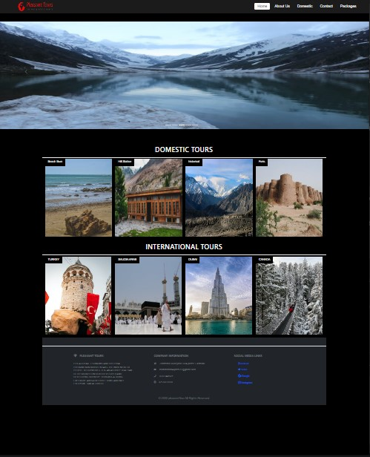

**Instruction Page**

1. Turkey
2. Saudia Arab
3. Contact Us

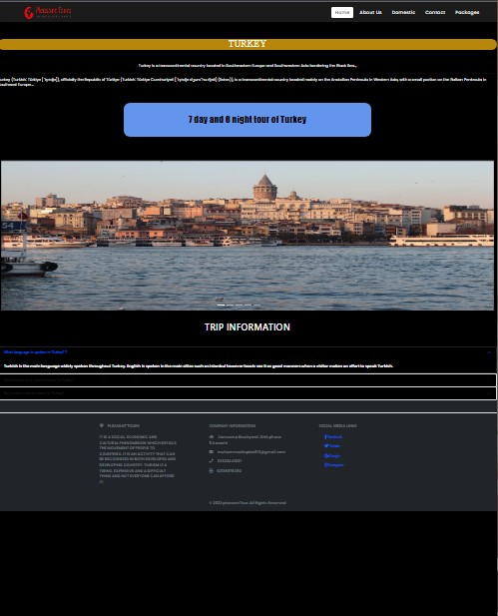

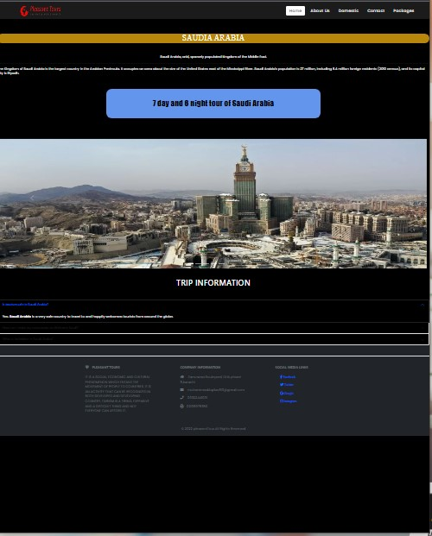

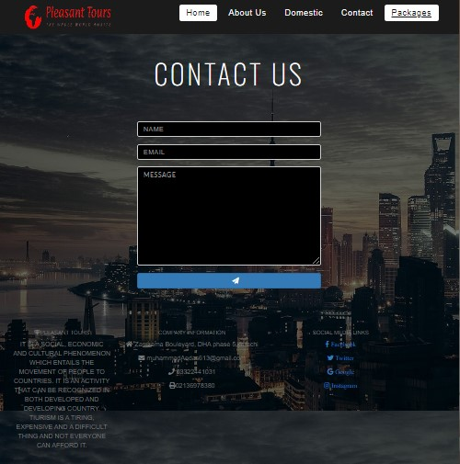

**TASK SHEET REVIEW 2**

|  |  |  |  |  |  |  |
| --- | --- | --- | --- | --- | --- | --- |
| Project Ref. No.: eP/Advertisement Portal Management System/01 | | Project  title | Date of Preparation of Activity Plan | | | |
| No | Task | PLEASANT TOURS | Actual | Actual | Team-mate | Status |
| Start Date | Days | Names |
| 1 | Navbar | 09/JAN/2023 | 1 | MUHAMMAD AQDAS | Complete |
| 2 | Main Body Navbar | 09/JAN/2023 | 1 | MUHAMMAD AQDAS | Complete |
| 3 | Footer | 09/JAN/2023 | 2 | MUHAMMAD AQDAS | Complete |
| 4 | Turkey | 09/JAN/2023 | 2 | MUHAMMAD AQDAS | Complete |
| 5 | Saudia | 09/JAN/2023 | 4 | MUHAMMAD AQDAS | Complete |
| 6 | Contact | 09/JAN/2023 | 3 | UBAID UR REHMAN | Complete |

**TASK SHEET REVIEW 3**

|  |  |  |  |  |  |  |
| --- | --- | --- | --- | --- | --- | --- |
| Project Ref. No.: eP/Advertisement Portal Management System/01 | | Project title | Date of Preparation of Activity Plan | | | |
| No | Task | Pleasant Tours | Actual  Start Date | Actual  Days | Team-mate  Names | Status |
| 1 | Mallam Jabba | 09/JAN/2023 | 3 | MUHAMMAD WASAy | Complete |
| 2 | Beach | 09/JAN/2023 | 4 | ABUBAKAR ALI | Complete |
| 3 | Hill | 09/JAN/2023 | 5 | ABUBAKAR ALI | Complete |
| 4 | hunza | 09/JAN/2023 | 1 | MUHAMMAD WASAY | Complete |